**Dockerfile**

[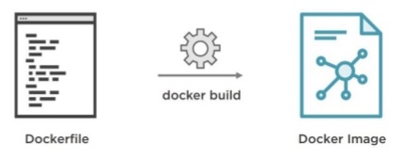](https://i.stack.imgur.com/jc2IW.jpg)

A Dockerfile is a simple text file that contains the commands a user could call to assemble an image.

Example, **Dockerfile**

FROM ubuntu:latest

MAINTAINER john doe

RUN apt-get update

RUN apt-get install -y python python-pip wget

RUN pip install Flask

ADD hello.py /home/hello.py

WORKDIR /home

# Docker Compose

[](https://i.stack.imgur.com/56AtK.png)

**Docker Compose**

* is a tool for defining and running multi-container Docker applications.
* define the services that make up your app in docker-compose.yml so they can be run together in an isolated environment.
* get an app running in one command by just running docker-compose up

Example, **docker-compose.yml**

version: "3"

services:

web:

build: .

ports:

- '5000:5000'

volumes:

- .:/code

- logvolume01:/var/log

links:

- redis

redis:

image: redis

volumes:

logvolume01: {}